Final term Lab Tasks-03
Joining: Displaying Data from Multiple Tables

Types of Joins
There are two main types of join conditions:
- Equijoins
- Non-equijoins
Additional join methods include the following:
- Outer joins
- Self joins
Exercise
- Display all the managers & clerks who work in Accounts and Marketing departments.
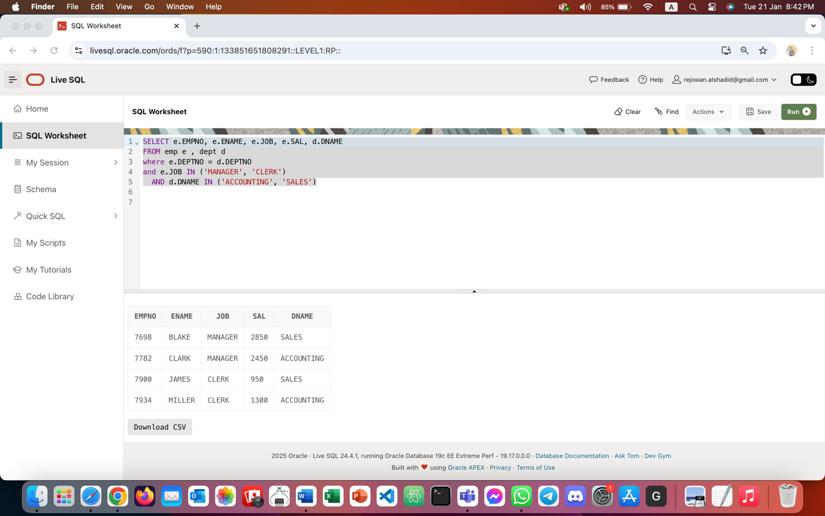
- 2. Display all the salesmen who are not located at DALLAS.
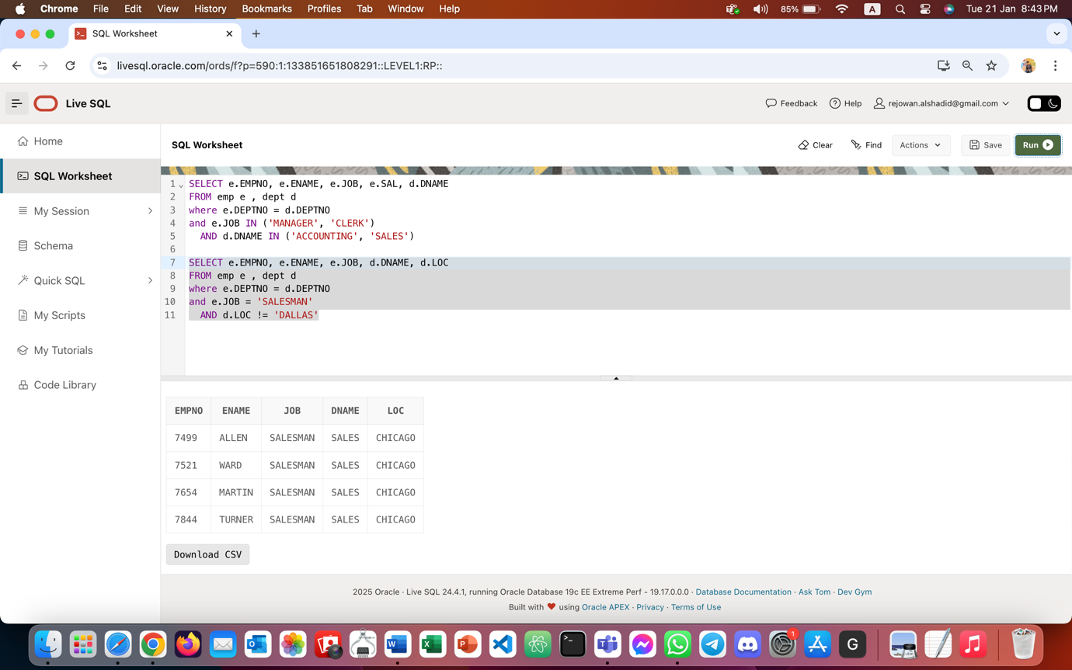

- Select the department name & location of all the employees working for CLARK.
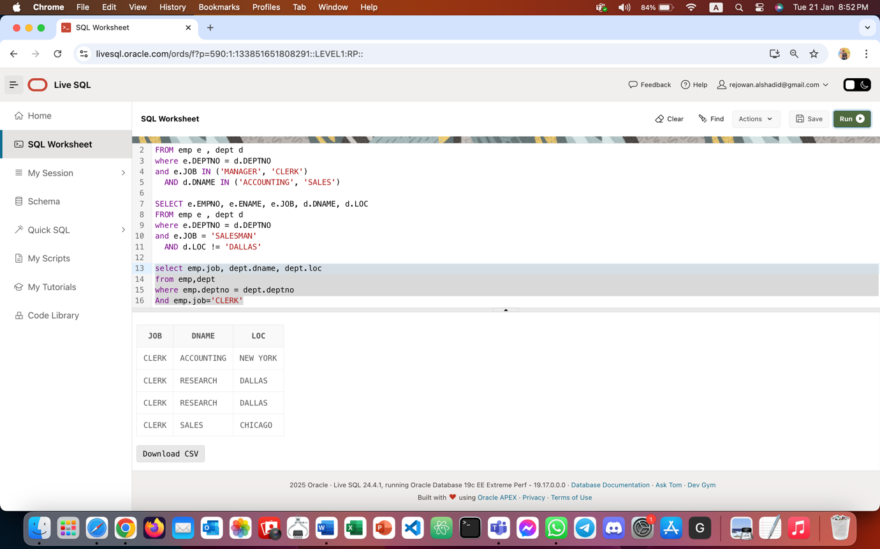

- Select all the departmental information for all the managers.
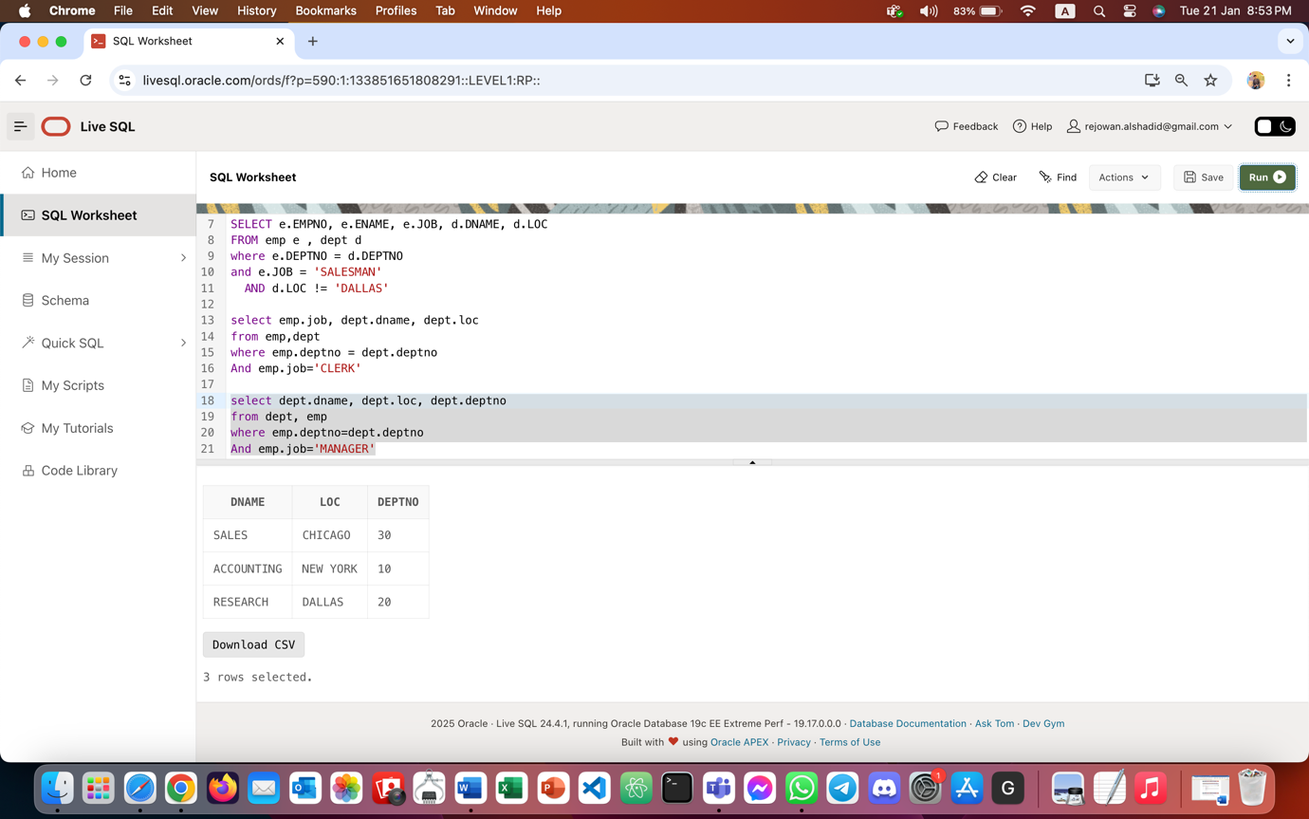

- Select all the employees who work in DALLAS.
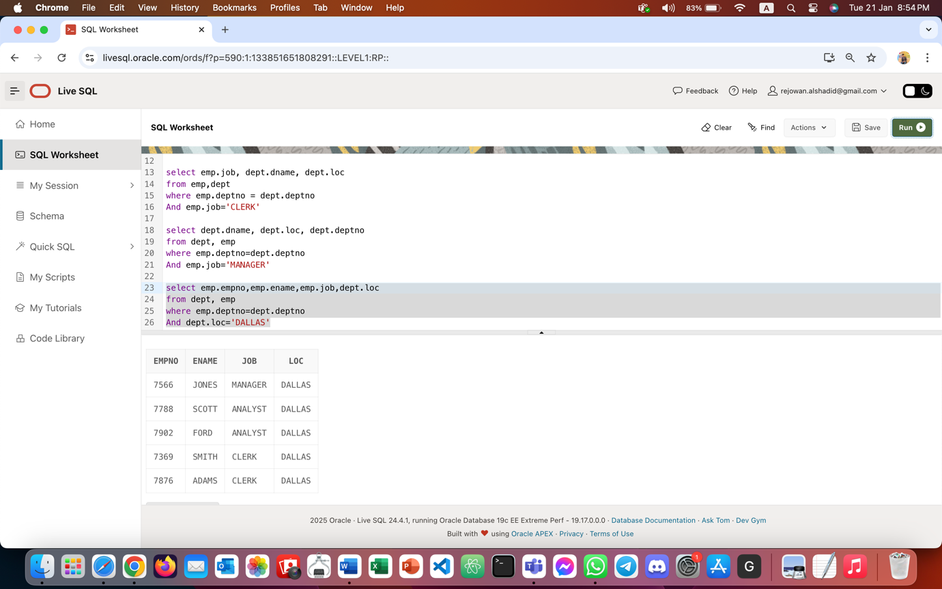
- Delete the records from the DEPT table that don’t have matching records in EMP.
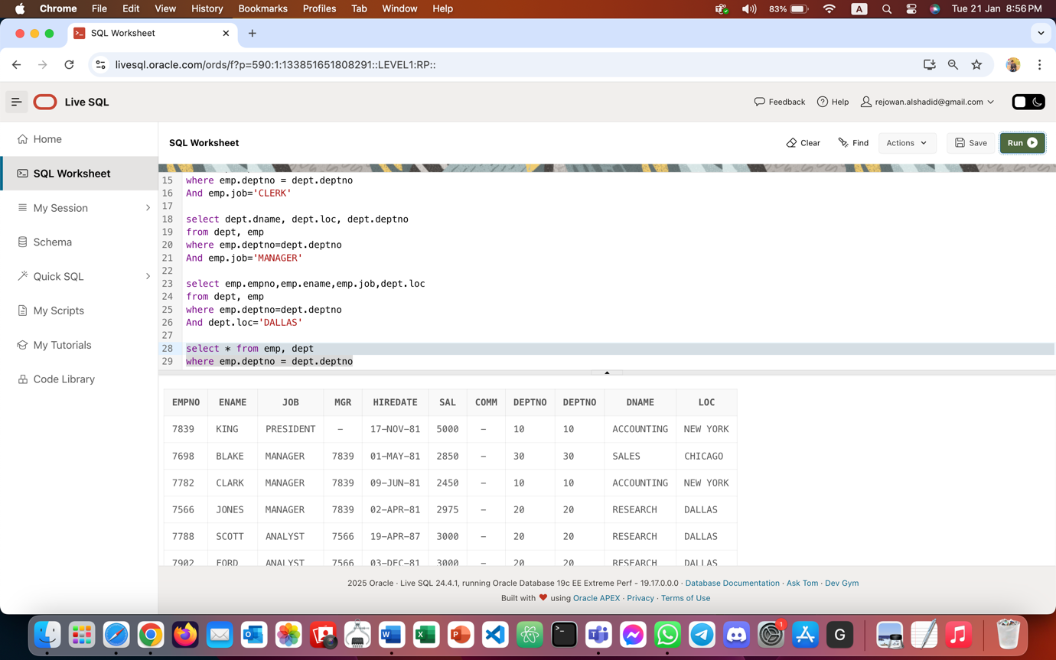

- Display all the departmental information for all the existing employees and if a department has no employees display it as “No employees”.
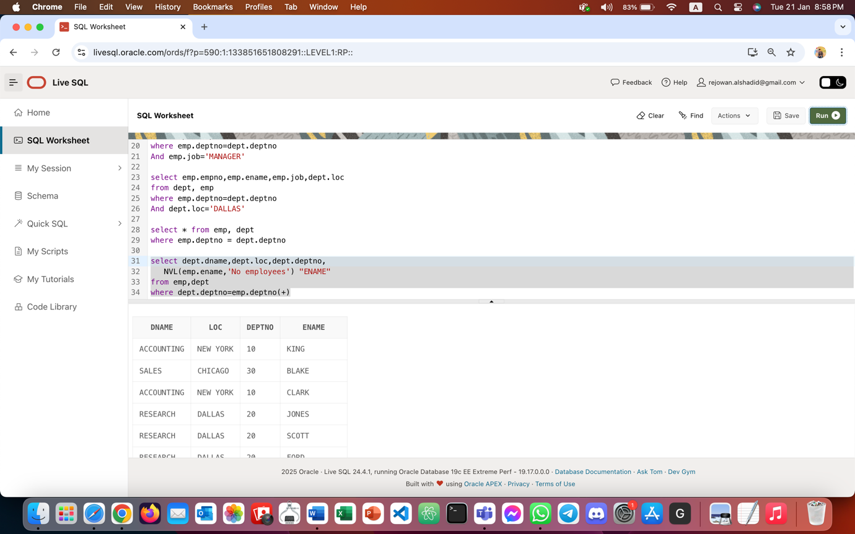

- Get all the matching & non-matching records from both the tables.
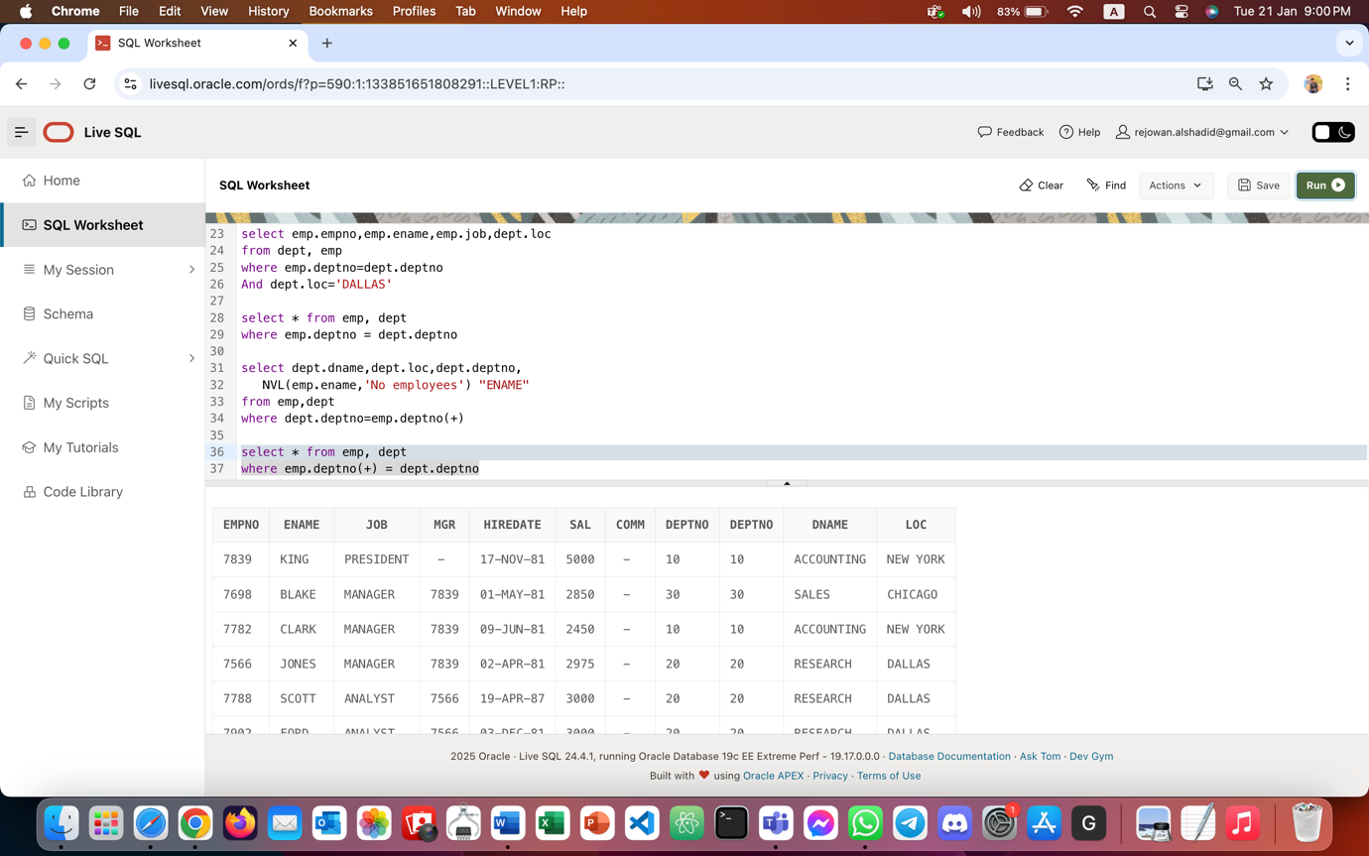
- Get only the non-matching records from DEPT table (matching records shouldn’t be selected).
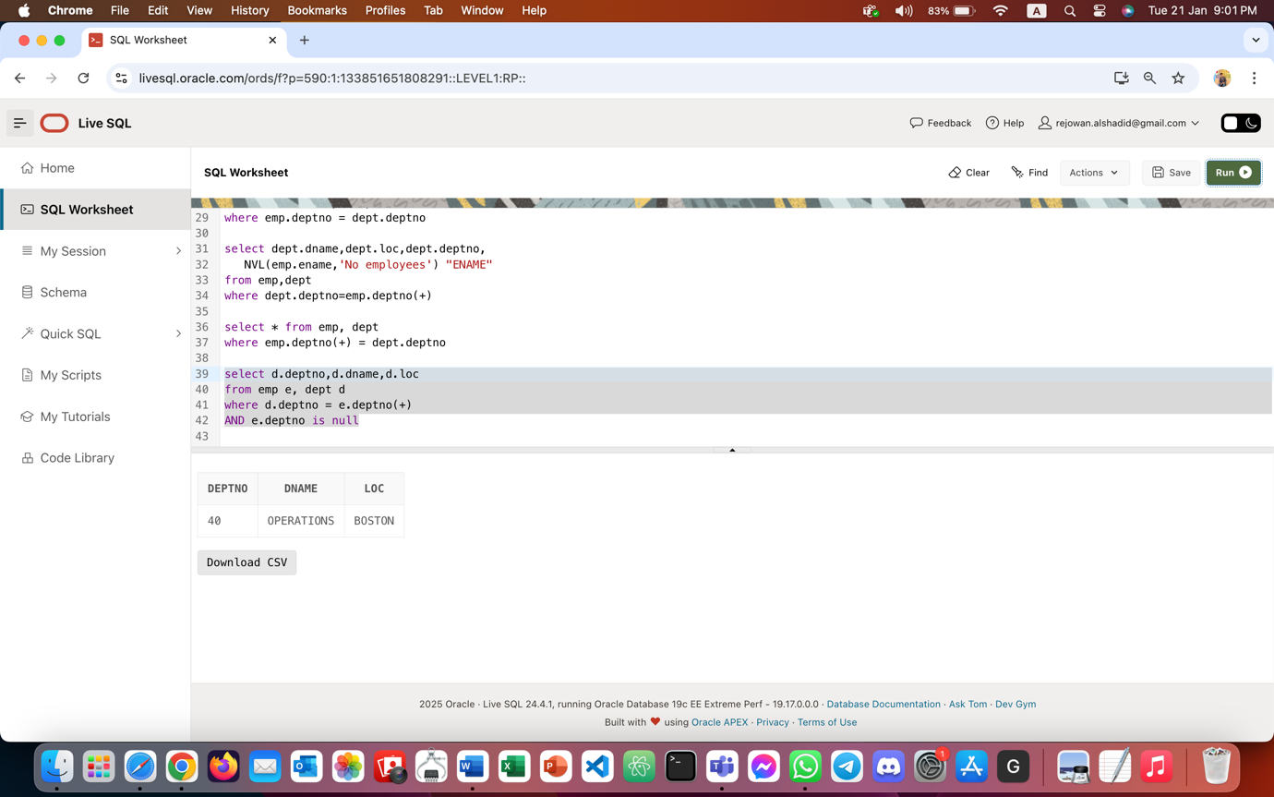

- Select all the employees’ names along with their manager names, and if an employee does not have a manager, display him as “CEO”.
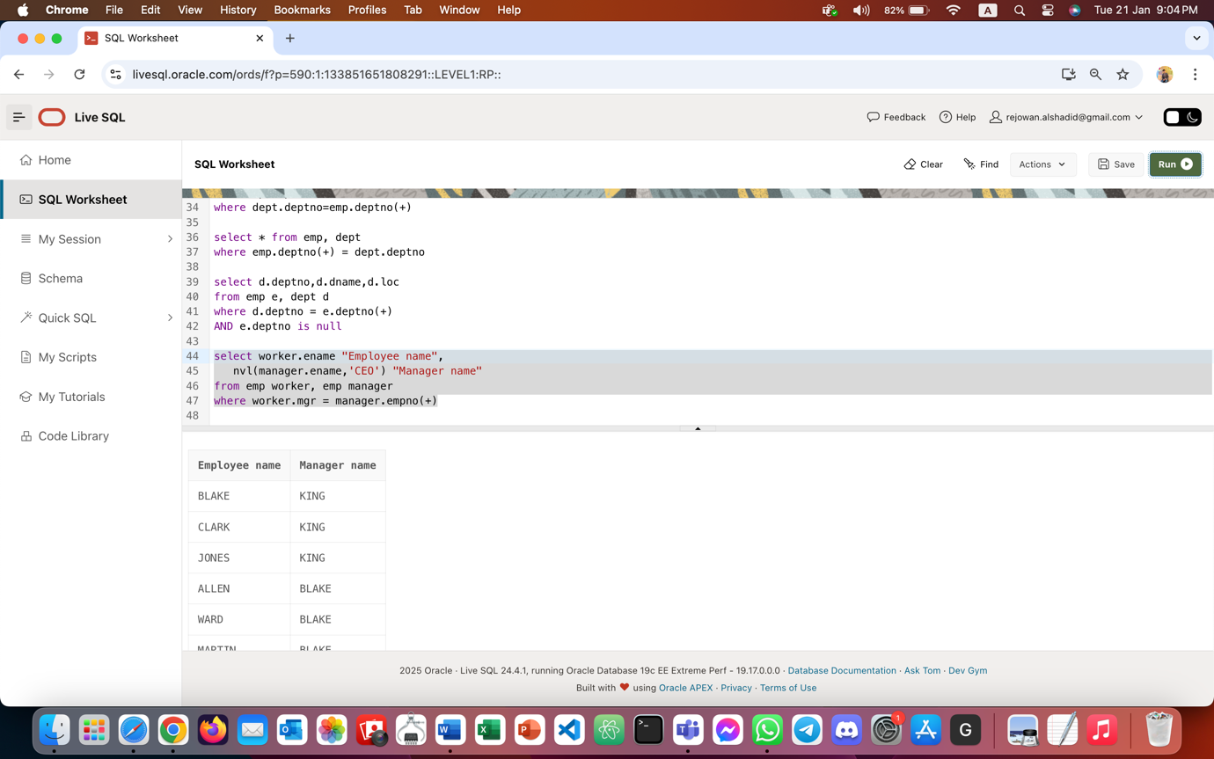

- Get all the employees who work in the same departments as SCOTT.
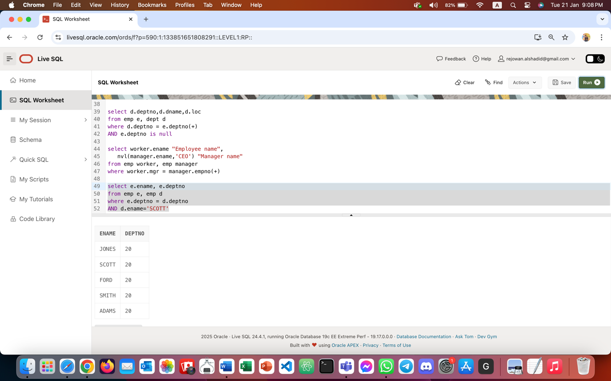
- Display all the employees who have joined before their managers.
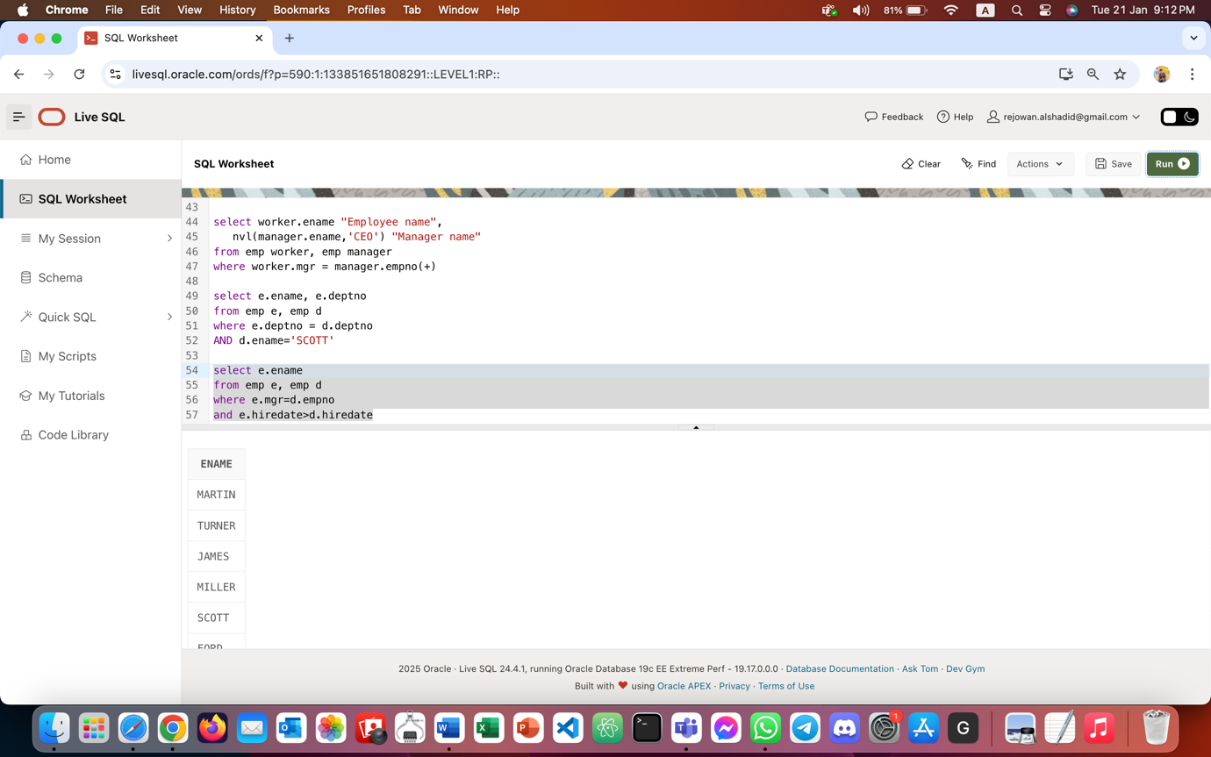
- List all the employees who are earning more than their managers.
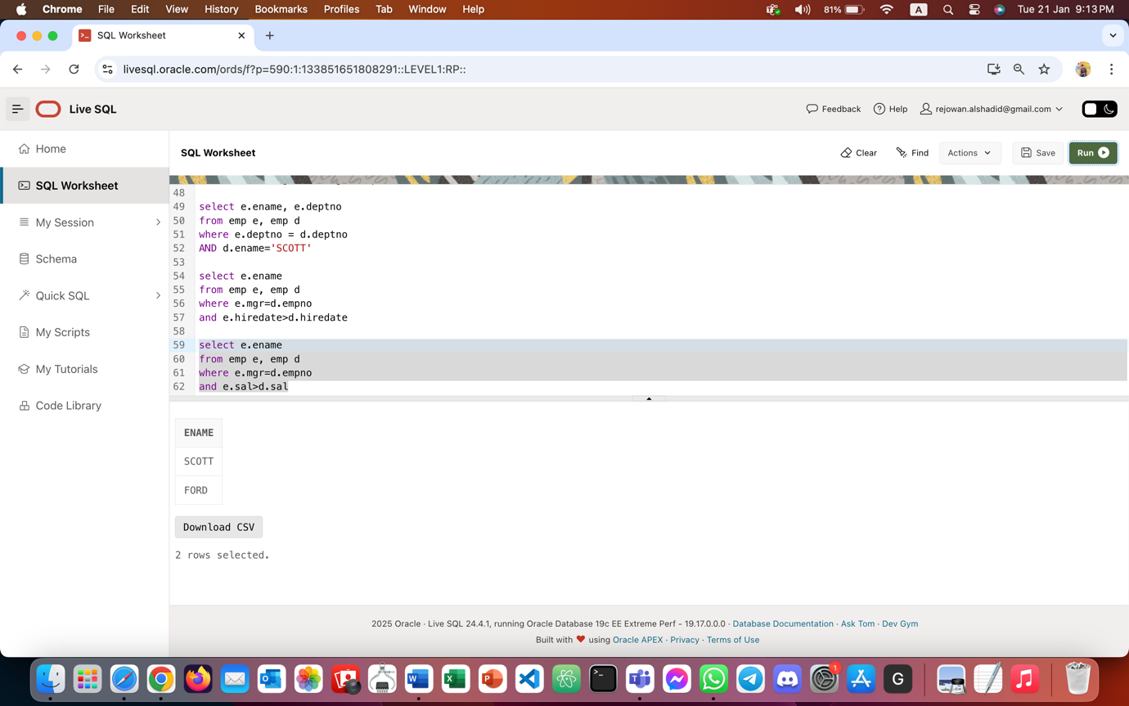

- Fetch all the employees who are earning the same salaries.
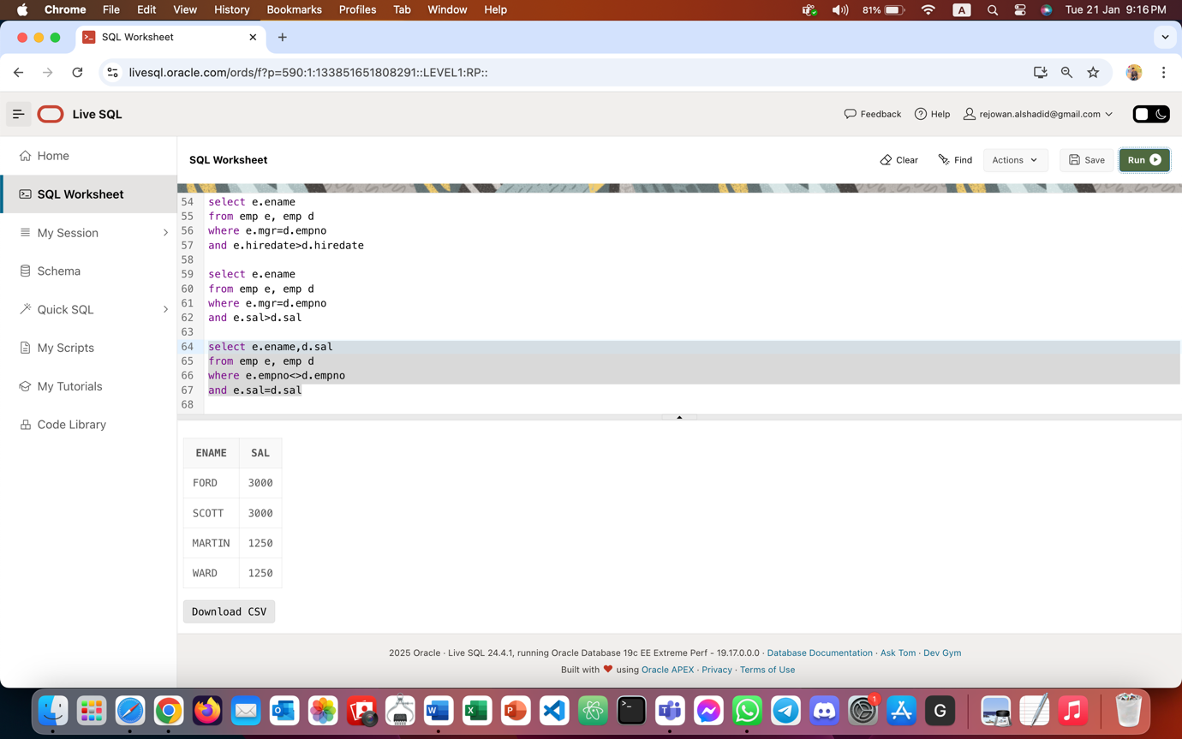

- Select all the employees who are earning the same as SMITH. Display employee name, his date of joining, his manager’s name & his manager's date of joining.
